
“Titan 72V Formula For Imperial Electric Racing Battery Pack Using Smart BMS”
A Project submitted to the
Savitribai Phule Pune University
In partial fulfillment of the requirement for
Final Year Electrical Engineering
By:
Mr. Gangode Prathmesh Raghunath (B400090080)
Mr. Fuge Sanket Bhagchand (B400090078)
Mr. Sase Nikhil Balasaheb (B400090091)
Under Guidance of
Prof. S.K. Awaze
(Electrical Engineering Department)

[2025-26]

DEPARTMENT OF ELECTRICAL ENGINEERING

2025-26



Department of Electrical Engineering
Dr. Vithalrao Vikhe Patil, College of Engineering, Ahmednagar.
2025-26
CERTIFICATE
A Report (Project stage-II)
On
“Titan 72V Formula For Imperial Electric Racing Battery Pack Using Smart BMS”

Submitted by:

Mr. Gangode Prathmesh Raghunath (B400090080)
Mr. Fuge Sanket Bhagchand (B400090078)
Mr. Sase Nikhil Balasaheb (B400090091)

Have satisfactorily completed the Bonafide work under my guidance and supervision in partial fulfillment of curriculum at Third/Final year Electrical Engineering of Savitribai Phule Pune University, Pune.

Prof. S.K. Awaze | Dr. Mrs. K. D. Vidhate
Project Guide | Project Coordinator
Dr. A.R. Laware | Dr. Ravindra R. Navthar
H. O. D. | Principal

Examiner’s Name &Sign

DEPARTMENT OF ELECTRICAL ENGINEERING
2025-26

ACKNOWLEDGMENT

We express our sincere gratitude to our respected guide Prof. S.K. Awaze for his continuous guidance, valuable suggestions, and encouragement throughout the project. His technical insights and support helped us complete this work successfully. We are also thankful to Dr. A.R. Laware (HOD) and Dr. Ravindra R. Navthar (Principal) for providing us with the opportunity and institutional support to utilize the department's resources effectively. We extend our special gratitude to Adiabatic Technologies Pvt. Ltd. for their industrial support and technical mentorship in understanding the complexities of high-voltage battery assembly and smart BMS integration. Finally, we thank our family and friends for their constant support and motivation during the completion of this project.

Project Team Members

Mr.Gangode Prathmesh Raghunath
Mr.Fuge Sanket Bhagchand
Mr. Sase Nikhil Balasaheb

ABSTRACT

The Titan 72V Formula Battery Pack project focuses on the design, development, and optimization of a high-performance lithium-ion battery system engineered for electric mobility and high-demand energy applications. The primary objective is to deliver a lightweight, efficient, and durable 72-volt power source capable of supporting sustained high-current discharge while maintaining optimal thermal stability and safety. The project integrates advanced cell balancing, a smart Battery Management System (BMS), and robust structural design to ensure reliability, longevity, and performance under extreme operating conditions. Emphasis is placed on modular architecture, enabling scalability for various electric vehicle platforms, from e-bikes to high-speed electric karts. Through detailed analysis of energy density, charge/discharge efficiency, and lifecycle testing, the Titan 72V Formula Battery Pack aims to set new benchmarks in power-to-weight ratio and system resilience, contributing to the evolution of sustainable electric propulsion technologies.

The transition toward sustainable mobility has accelerated the demand for high-performance energy storage systems. In the context of competitive electric racing, battery packs must balance high energy density, extreme discharge rates, and rigorous safety standards. This project details the engineering, design, and implementation of the "Titan 72V Formula Electric Racing Battery Pack."
A 20S-5P configuration using high-discharge Lithium-ion 18650 cells was developed to provide a nominal 72V output. The integration of a Smart Battery Management System (BMS) allows for real-time monitoring of cell voltages, temperatures, and State of Charge (SOC) via CAN and Bluetooth protocols. Key performance indicators such as thermal stability under load and SOC accuracy were validated through MATLAB simulations. The result is a robust, lightweight, and efficient power source capable of meeting the dynamic demands of Formula-style electric racing.

Sponsorship Letter


We, the undersigned final-year students of the Department of Electrical Engineering Dr. Vitthalrao Vikhe Patil college of Engineering, would like to express our sincere gratitude to Adiabatic Technologies Pvt. Ltd. for providing us with an exceptional opportunity to undertake an academic sponsorship project as part of our final-year curriculum.

Our project, titled “Titan 72V Formula Smart BMS Electric Racing Battery Pack,” was carried out under the guidance and technical mentorship of the engineering team at Adiabatic Technologies Pvt. Ltd. This collaboration allowed us to gain in-depth knowledge of the design, testing, and simulation processes involved in developing a high-performance lithium-ion battery system for electric mobility applications.

Through this project, we were able to explore key technical domains including battery pack architecture, cell selection and configuration, Smart BMS integration, thermal management, and safety systems. The exposure to real-world R&D practices helped us understand the importance of testing validation, data analysis, and performance evaluation in achieving efficiency and reliability in energy storage systems.

We extend our heartfelt thanks to the management and engineers of Adiabatic Technologies Pvt. Ltd. for their constant guidance, mentorship, and support throughout the project duration. Their expertise and encouragement played a vital role in enhancing our practical understanding and technical competence.

This project has been an invaluable learning experience, bridging the gap between academic theory and industrial application, and has inspired us to pursue further research and innovation in the field of electric vehicle technology and renewable energy systems.

We once again express our sincere appreciation to Adiabatic Technologies Pvt. Ltd. for their cooperation, trust, and technical guidance in making this project a successful and enriching endeavor.

Team Members:
  - Mr. Gangode Prathmesh Raghunath (B400090080)
  - Mr. Fuge Sanket Bhagchand (B400090078)
  - Mr. Sase Nikhil Balasaheb (B400090091)

Department of Electrical Engineering
Dr.Vitthal Rao Vikhe Patil college of Engineering
Academic Year: [2025–2026]

INDEX

Sr. No | Title | Pages No
1 | Introduction | 11
2 | Literature survey | 12
3 | Problem Statement | 15
4 | Need of project | 16
5 | Objective of project | 17
6 | System Development, Battery Pack Manufacturing & Methodology | 18
7 | Mechanical & Structural Design Topology | 31
8 | System Design & Calculations | 32
8 | Testing Process | 34
9 | Performance analysis | 45
10 | Future Scope | 51
9 | Conclusion | 52
11 | References | 53

LIST OF FIGURES

Fig No | Title | Page No
4.1 | Block Diagram of BMS | 21
4.2 | BMS | 22
4.3 | System Control Topology | 23
4.4 | Cell Balancing Matrix | 24
7.1 | Thermal Characteristic Curve | 32
7.2 | Testing Flow Chart | 34
8.3 | Final Project Design | 47

LIST OF TABLES

SR.NO | TABLES | PAGES
1 | Cell Grading Table | 17
2 | Quality Control Measures | 20
3 | BMS Summary Table | 23
4 | Battery System Components Summary Table | 26
5 | Cell Chemistry Comparison Table | 27-28
6 | Experimental Validation Results Table | 40
7 | Testing & Results Table | 41

LIST OF ABBREVIATIONS
Abbreviation | Full Form
BMS | Battery Management System
EV | Electric Vehicle
SOC | State of Charge
SOH | State of Health
CAN | Controller Area Network
UART | Universal Asynchronous Receiver Transmitter
ADC | Analog-to-Digital Converter
OCV | Open Circuit Voltage
VCU | Vehicle Control Unit
BLDC | Brushless DC Motor
NMC | Nickel Manganese Cobalt
LFP | Lithium Iron Phosphate
EKF | Extended Kalman Filter
FRP | Fiber Reinforced Plastic
SIL | Software-in-the-Loop
MATLAB | Matrix Laboratory

CHAPTER 1

INTRODUCTION

Electric vehicle (EV) technology has emerged as the primary solution to the environmental degradation caused by internal combustion engines. In high-stakes environments like Formula student racing, the battery pack is not merely a fuel tank; it is a complex electronic system that determines the vehicle's acceleration, weight distribution, and safety.
The performance of an electric racing vehicle depends heavily on the battery's ability to supply peak current during acceleration without suffering from significant voltage sag or overheating. Traditional battery packs often lack modularity and real-time intelligence, leading to unexpected failures during competition.

The rapid evolution of electric mobility and renewable energy technologies has significantly reshaped the modern transportation landscape. With the global emphasis on reducing carbon emissions and minimizing dependence on fossil fuels, electric vehicles (EVs) have emerged as a sustainable and efficient alternative. Central to the success of any electric vehicle is the battery system, which serves as its primary energy source. The performance, range, and reliability of an EV depend largely on the design, chemistry, and management of its battery pack.

In this context, the Titan 72V Formula Battery Pack Project was conceived to develop a high-performance lithium-ion battery system specifically tailored for electric racing applications. The goal is to design a 72-volt power unit capable of delivering high current, fast response, and sustained performance under demanding conditions—ideal for use in electric racing bikes, go-karts, and lightweight performance EVs. The project seeks to achieve an optimal balance among energy density, safety, thermal stability, cost efficiency, and lifecycle durability.

The Titan 72V Formula system incorporates advanced lithium-ion cells, integrated with a Smart Battery Management System (BMS) that ensures real-time monitoring and protection against critical failures such as overcharge, over-discharge, overcurrent, and thermal runaway. The Smart BMS also supports data communication, enabling state-of-charge (SOC), state-of-health (SOH), and performance diagnostics to be monitored through digital interfaces for improved control and reliability.

The project not only enhances understanding of battery architecture and energy optimization but also contributes to the advancement of sustainable mobility solutions by promoting safer, smarter, and cleaner energy storage technologies.

CHAPTER 2


LITERATURE SURVEY

1. Lithium-Ion Battery Technology
Lithium-ion (Li-ion) batteries have become the dominant energy storage solution due to their high energy density, low self-discharge rate, and long cycle life. According to Nittaet al. (2015), advances in electrode materials—such as nickel manganese cobalt (NMC) and lithium iron phosphate (LFP)—have significantly enhanced performance and safety compared to earlier chemistries. However, challenges remain in managing temperature rise and ensuring uniform cell performance across large battery packs.

2. Battery Pack Design and Configuration
Research by Ecker et al. (2019) highlights the importance of proper cell arrangement, interconnection design, and packaging in improving energy utilization and reducing losses. Modular battery pack structures have been shown to improve scalability and maintenance efficiency. In high-voltage applications (above 60V), precise control of series and parallel configurations is crucial to achieve the desired power output while maintaining safety and efficiency.

3. Battery Management Systems (BMS)
The integration of a BMS is critical for monitoring voltage, current, temperature, and state of charge (SOC) of individual cells. According to Plett (2015), an intelligent BMS ensures balanced charging, prevents overcharging and deep discharging, and enhances the overall lifespan of the battery pack. Recent innovations include the use of microcontrollers and wireless communication for real-time monitoring and fault detection.

4. Thermal Management and Safety
Thermal behavior plays a vital role in battery performance and safety. Studies by Bandhauer et al. (2011) have demonstrated that effective cooling methods—such as air or liquid-based systems—can significantly extend the battery’s operational life by maintaining optimal temperature ranges. Poor thermal management may lead to uneven cell aging or, in extreme cases, thermal runaway.

5. Applications in Electric Mobility
Numerous electric vehicle prototypes and commercial models have adopted 72V battery systems due to their balance between power output and safety. Research from Sharma et al. (2020) emphasizes that a 72V configuration is ideal for medium to high-performance electric vehicles, providing sufficient torque and speed while maintaining manageable system complexity.

6. State of Charge (SOC) and State of Health (SOH) Estimation
Accurate estimation of SOC and SOH is essential for efficient battery utilization and longevity. Hu et al. (2012) demonstrated that advanced estimation techniques such as Kalman Filters, Extended Kalman Filters (EKF), and neural network-based models provide accurate battery condition monitoring. Reliable SOC estimation improves driving range prediction, while SOH monitoring helps identify battery degradation and maintenance requirements.

7. Fast Charging Technologies
The adoption of electric vehicles depends heavily on charging infrastructure and charging speed. Studies by Omar et al. (2017) indicate that fast-charging systems significantly reduce charging time but may increase battery temperature and degradation if not properly controlled. Smart charging algorithms and adaptive charging profiles are being developed to balance charging speed with battery health preservation.

8. Cell Balancing Techniques
Cell imbalance is a common issue in battery packs connected in series. Research by Daowd et al. (2011) highlights that active and passive cell balancing methods help maintain uniform voltage levels across cells. Active balancing transfers energy between cells, improving efficiency, while passive balancing dissipates excess energy as heat. Effective balancing enhances battery capacity utilization, safety, and lifespan.

9. Battery Modeling and Simulation
Battery modeling plays an important role in predicting performance under different operating conditions. According to Tremblay and Dessaint (2009), simulation tools such as MATLAB/Simulink enable engineers to analyze charging, discharging, thermal behavior, and fault conditions before physical implementation. Battery models help reduce development costs and improve design optimization.

10. Renewable Energy Integration
Lithium-ion battery packs are increasingly used in renewable energy systems to store energy generated from solar and wind sources. Research by Divya and Østergaard (2009) suggests that battery energy storage systems improve grid stability, load balancing, and energy availability. The integration of smart battery management systems further enhances the efficiency of renewable energy applications.

11. Battery Aging and Degradation Mechanisms
Battery aging is influenced by charge-discharge cycles, temperature variations, and operating conditions. Studies by Vetter et al. (2005) identified capacity fade and internal resistance growth as major degradation mechanisms in lithium-ion batteries. Understanding aging behavior helps manufacturers develop strategies to improve battery life and reliability.

12. Future Trends in Battery Technology
Emerging battery technologies such as solid-state batteries, lithium-sulfur batteries, and sodium-ion batteries are being developed to overcome limitations of conventional lithium-ion batteries. According to Goodenough and Park (2013), these technologies promise higher energy density, improved safety, and lower costs. Future battery systems are expected to incorporate advanced materials, intelligent control systems, and enhanced thermal management solutions for next-generation electric mobility applications.

13. Battery Energy Density Improvement
Energy density is one of the most critical parameters influencing the performance of electric vehicle battery packs. Research by Tarascon and Armand (2001) highlighted the importance of advanced cathode and anode materials in increasing the energy storage capacity of lithium-ion batteries. Higher energy density allows vehicles to achieve longer driving ranges without significantly increasing battery size or weight. Continuous developments in silicon-based anodes and high-nickel cathodes have contributed to substantial improvements in battery performance.

14. Electrical Interconnection and Busbar Design
The efficiency of a battery pack depends heavily on the quality of electrical interconnections. Kim et al. (2018) reported that optimized busbar design reduces electrical resistance, minimizes heat generation, and improves current distribution among cells. Proper welding techniques, including laser welding and ultrasonic welding, enhance connection reliability and mechanical strength while reducing energy losses.

15. Fault Detection and Diagnostics
Battery fault diagnosis is essential for preventing failures and ensuring safe operation. Studies by Sun et al. (2015) proposed advanced fault detection methods using voltage, temperature, and current monitoring. Machine learning algorithms are increasingly being employed to identify abnormal operating conditions, internal short circuits, sensor failures, and thermal anomalies before they lead to catastrophic failures.

16. Battery Pack Enclosure Design
The mechanical enclosure of a battery pack provides structural support, environmental protection, and safety. According to Feng et al. (2018), battery enclosures must be lightweight, durable, and capable of protecting cells from vibration, moisture, dust, and impact loads. Materials such as aluminum alloys and composite structures are commonly used due to their favorable strength-to-weight ratio.

PROBLEM STATEMENT
The critical limitation of performance electric drivetrains lies in the transient stability of the battery cells during rapid acceleration and deceleration. Under peak load demands, high discharge currents cause internal voltage drop (voltage sag) and rapid heat generation due to internal cell resistances. Without intelligent monitoring and precise thermal management, these factors can trigger localized degradation, accelerated capacity loss, or catastrophic thermal runaway.
Conventional off-the-shelf battery configurations often lack the cell-level modularity, high continuous current capabilities, and fast communication buses needed for track environments. This project focuses on solving these operational challenges through a systematic design approach for a custom 72V racing battery pack managed by an edge-computed Smart Battery Management System.

- Structural Project Objectives

    - Electrochemical Engineering: Structural design and optimization of a high-output 72V, 15Ah tractive battery pack using premium Lithium-ion 18650 cells.
    - Intelligent Management Integration: Development of a Smart BMS to maintain uniform cell parameters through passive balancing algorithms.
    - Analytical and SIL Simulation: Modeling of state estimation and thermal rise trajectories within MATLAB/Simulink frameworks.
    - Industrial Testing: Empirical verification of system efficiencies and safety isolation barriers under variable load conditions.

CHAPTER 3

NEED OF PROJECT
1. Global Transition to Sustainable Mobility
- Combustion Engine Replacement: Traditional internal combustion engines contribute to significant environmental degradation. As electric vehicles continue to replace them, there is a rapidly growing global demand for advanced energy storage systems that can reliably deliver both power and endurance.
- Bridging the Engineering Gap: There is a pressing need for customized, real-world solutions that bridge the existing gap between theoretical energy design and practical application in the evolving green mobility sector.

2. Overcoming Performance Bottlenecks in Racing EVs
- Mitigating Transient Instability: In track and racing environments, conventional off-the-shelf battery configurations often lack the cell-level modularity and high continuous current capabilities required.
- Managing "Voltage Sag": Under rapid acceleration and deceleration, high discharge currents cause internal voltage drops (voltage sag) and sudden heat spikes due to internal cell resistances. This project addresses the need for custom-engineered battery architectures (such as the 20S-5P configuration) to supply peak current without suffering from performance loss.

3. Safety Risks and Advanced Battery Management
- Preventing Thermal Runaway: Without an intelligent monitoring system, rapid heat generation can trigger localized cell degradation, capacity loss, or catastrophic thermal runaway.
- Replacing Static Hardware: Traditional battery packs often lack real-time intelligence. There is a critical need to replace standard, simple protection circuits with edge-computed Smart Battery Management Systems (BMS) that can accurately handle real-time cell balancing, fault detection, and precise State of Charge (SOC) tracking.

4. Lightweight and Compact Architecture
- Optimizing Vehicle Dynamics: For competitive Formula student racing, vehicle weight directly dictates cornering dynamics, acceleration, and handling. This project satisfies the need to use chemistry with high specific gravimetric density (such as Nickel Manganese Cobalt - NMC) to minimize traction system weight while maximizing power output.

  - The Titan 72V Formula Battery Pack Project was initiated to meet this need by designing a next-generation lithium-ion battery system optimized for racing and high-performance electric vehicles. The project focuses on developing a 72V battery pack that offers:
- High power output for rapid acceleration and dynamic load conditions.
- Enhanced safety through a Smart Battery Management System (BMS) with real-time monitoring.
- Improved thermal management to maintain cell stability and longevity.

  - By developing the Titan 72V Formula Electric Racing Battery Pack, this project contributes to:
- Advancing clean energy technology for sustainable transportation.
- Supporting the Make in India and green mobility initiatives.
- Promoting research and innovation in battery system engineering.

  - The Titan 72V Electric Racing Battery Pack Project focuses on the design and development of a customized lithium-ion battery pack optimized for high-speed electric racing applications. A 72V system is selected as it offers an optimal balance between power output, system efficiency, and motor compatibility, making it ideal for lightweight racing vehicles.

3.1 Project Objectives
- To design a 72V high-capacity Lithium-ion battery pack suitable for racing.
- To perform thermal analysis and ensure safety during high-discharge cycles.
- To develop a communication interface for real-time telemetry and monitoring.
- To design a 72V battery pack configuration using suitable lithium-ion cells for racing performance. To calculate and optimize the electrical parameters such as voltage, capacity, energy, and C-rate.
- To select appropriate components, including Battery Management System (BMS), fuses, busbars, and thermal management systems.
- To assemble and integrate the battery pack with mechanical protection, insulation, and cooling arrangements.
- To test and validate the battery pack for performance, efficiency, and safety under racing load conditions.

CHAPTER 4

SYSTEM DEVELOPMENT & BATTERY PACK MANUFACRING
4.1 Battery Cell Grading and Sorting
Before battery pack assembly, lithium-ion cells are subjected to grading and sorting. Cells are tested for voltage, capacity, and internal resistance to ensure uniform electrical characteristics.
Process Flow
- Cell Incoming Inspection
- Cell Grading
- Cell Sorting
- Cell Holder Assembly
- Spot Welding
- Visual Inspection
- BMS and Connector Welding
- Wire and Connector Soldering
- Insulation and FRP Packaging
- Semi-Finished Battery Pack
Importance
- Ensures uniform cell performance.
- Reduces imbalance between cells.
- Improves battery life and safety.
- Enhances charging and discharging efficiency.

4.2 Detailed Manufacturing Process
1. Cell Incoming Inspection
This is the first stage where battery cells received from suppliers are inspected.
Activities Performed
- Verification of cell specifications.
- Checking manufacturing batch numbers.
- Visual inspection for dents, leakage, corrosion, swelling, or physical damage.
- Open Circuit Voltage (OCV) measurement.
- Documentation and traceability recording.
Purpose
- Eliminate defective cells before assembly.
Equipment Used
- Digital Multimeter
- Cell Voltage Tester
- Inspection Workstation
  - Cell Grading
Parameters Measured
- Voltage (V)
- Capacity (Ah)
- Internal Resistance (mΩ)

Example:
Grade | Voltage Range | Internal Resistance
A Grade | 3.65 – 3.70 V | Low
B Grade | 3.60 – 3.65 V | Medium
Reject | Below Standard | High

  - Purpose
- Ensure uniform cell performance.
- Minimize imbalance during operation.
Benefits
- Higher efficiency.
- Better cycle life.
- Improved safety.
  - Cell Sorting
  - Cells having similar characteristics are grouped together.
Sorting Criteria
- Voltage Matching
- Capacity Matching
- Internal Resistance Matching
Purpose
  - When cells with similar characteristics are connected together, they charge and discharge uniformly.
Advantages
- Reduced balancing requirement.
- Increased battery lifespan.
- Improved energy utilization.
  - Cell Holder Assembly
  - Cell holders are used to position and secure the battery cells.
Process
- Arrange cells according to pack configuration.
- Insert cells into plastic cell holders.
- Verify spacing and orientation.
Functions of Cell Holders
- Maintain cell alignment.
- Prevent short circuits.
- Improve heat dissipation.
- Reduce vibration effects.
Example
  - For a 72V battery pack, cells may be arranged in:
- Series Connection (S)
- Parallel Connection (P)

Example Configuration:
- 20S10P
- 20 series groups with 10 cells in parallel.
  - Ready for Spot Welding
Before welding:
Verification
- Cell polarity check.
- Nickel strip positioning.
- Holder alignment inspection.
Safety Checks
- Voltage verification.
- Insulation verification.
  - Spot Welding
Spot welding is used to connect cells using nickel strips.
Process
- Nickel strips are placed on cell terminals.
- Spot welding electrodes apply pressure.
- High current pulse generates heat.
- Nickel strip bonds with cell terminal.
Advantages
- Low resistance connection.
- Strong mechanical joint.
- Minimal heat damage.
  - Materials Used
- Pure Nickel Strip
- Nickel-Plated Steel Strip
Importance
Spot welding forms the electrical pathway between cells and determines pack reliability.
  - visual Inspection
After welding, the pack undergoes visual inspection.
Inspection Points
- Weld quality.
- Nickel strip alignment.
- Loose connections.
- Burn marks.
- Cell damage.
Purpose
  - Detect manufacturing defects before proceeding further.
  - BMS and Connector Welding
  - The Battery Management System (BMS) is integrated into the pack.
Functions of BMS
- Overcharge Protection
- Overcurrent Protection

Process
  - Balance wires connected to cell groups.
  - Main positive and negative terminals connected.
  - Connectors welded to output terminals.
Importance
The BMS acts as the "brain" of the battery pack.
  - Wire and Connector Soldering
Electrical wiring is completed in this stage.
Components Connected
- Power Wires
- Balance Wires
- Charging Connector
- Discharge Connector
Soldering Process
- Surface cleaning.
- Flux application.
- Solder joint formation.
- Joint inspection.
Quality Requirements
- Low resistance connection.
- Mechanical strength.
- Reliable conductivity.
  - Insulation and FRP Packaging
The battery pack is insulated and mechanically protected.
Materials Used
- Fish Paper
- Kapton Tape
- Heat Shrink Sleeve
- FRP (Fiber Reinforced Plastic)
Functions
- Electrical insulation.
- Mechanical protection.
- Thermal isolation.
- Moisture resistance.
Advantages of FRP
- Lightweight.
- High strength.
- Corrosion resistant.
- Electrically insulating.

  - Semi-Finished Battery Pack
At this stage:
Completed Components
  - Cell Assembly
  - Spot Welding
  - BMS Installation
  - Wiring
  - Insulation
Pending Activities
- Functional testing.
- Aging test.
- Final quality inspection.

  - Quality Control Measures
- Stage-wise Inspection
Stage | Inspection
Incoming Cells | Voltage & Physical Inspection
Grading | Capacity & Resistance
Spot Welding | Weld Strength
BMS Integration | Wiring Verification
Final Assembly | Functional Testing
Aging Test | Performance Validation

4.3 Methodology










- Designing the battery pack architecture
- Understanding cell selection and configuration
Learning about thermal and safety management.
- Observing assembly processes
- Participating in performance testing and data evaluation
4.4 System Development
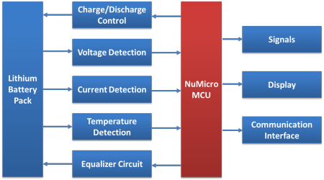

Figure 4.1 Block Diagram of BMS
- The solution is an electronic device capable of monitoring and managing the battery, using an intelligent protection board based on the microcontroller, which has the advantages of convenient parameter adjustment, high flexibility, and better functional design.
- The number of batteries for CPB usually does not exceed 20; the protection board can be categorized as pure hardware or MCU-based smart lithium battery protection boards.

BMS
- 5V working voltage is supported for the I/O, and expanded selection range of peripheral analog devices to effectively lower cost for the customers
- multi-channel high-speed 12-bit ADC to respond to instant voltages, currents and temperatures changes of each battery, so that processing can be performed in real-time to prevent overcharging, over-discharge and over-temperature of batteries
- there are rich communication ports on-board including UART, IIC, SPI, and CAN, able to satisfy communication needs such as simulating front-end IC with peripherals, host computer and chargers simultaneously
- super low-power standby and operations, able to effectively reduce the power consumption of the system and extend battery operating time
- -40℃ to 85℃ / 105℃ operating range can effectively ensure the stability and reliability of system operations
- provides several packaging and Flash sizes to give you more choices

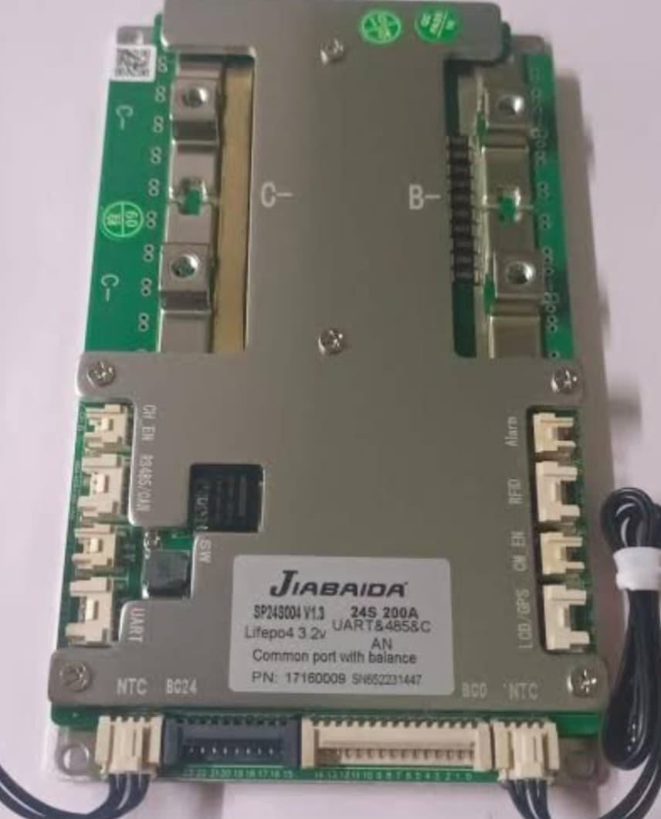
Figure 4.2 Jiabiada BMS
- A Jiabaida (JBD) 24S 200A Smart BMS is a battery management system designed for 8-24 series lithium-ion or LiFePO4 battery packs, providing advanced protection and balancing functions. It features 200A continuous current handling, Bluetooth and CAN connectivity for remote monitoring and configuration, active cell balancing, and multiple protection mechanisms against overcharge.

- Summary Table

Series (S) | 24S
Continuous Discharge Current (A) | 200A
Battery Type | Lithium-ion Battery
Number of Cells in Series | 24S
Brand | Jiabaida
Communication Protocol | Bluetooth, CAN, Wi-Fi, RS485
Application | E-Vehicle
Voltage | 3.2V
Current | 200A

4.5 System Control Topology
- The system architecture integrates a centralized management layout where individual analog cell lines monitor parameters at the hardware layer and relay datasets directly to the processing unit.
Voltage Sensors
CAN Telemetry
Thermal Array
Central Smart BMS
Microcontroller
MOSFET Switch
Current Shunt

Figure 4.3 System Control Topology

4.6 Battery Management System Architecture Theory
- Accurate State of Charge (SOC) estimation is critical to prevent deep-discharge conditions and to optimize tracking strategy during a competition. The primary method utilized within the Titan system is Coulomb Counting, which monitors the current passing through the pack over time. The continuous time-domain equation governing this process is written as:
SOC(t) = SOC(t0) - ∫t t (η · I(τ) / Cnominal) dτ
0
- Where SOC(t0) is the initial state initialization point, I(τ) represent the instantaneous tractive line current, Cnominal is the total rated current capacity, and η is the electrochemical coulombic efficiency factor (typically η ≈ 0.98 during standard discharge conditions).

- Passive vs. Active Cell Balancing Matrix
- Manufacturing tolerances introduce slight variations in internal resistance and capacity across individual cells. During cyclical operations, these variances can cause cell voltages to drift apart. Without correction, the entire pack's usable capacity becomes limited by the weakest cell group in the series string.
- The Titan Smart BMS uses a passive balancing architecture with custom-switched bleed resistors. When the controller detects that a specific parallel group has exceeded the voltage threshold relative to its neighbors, a logic-level MOSFET switches on.
R_bleed
Cell Group
BMS Logic Gate
Figure 4.4 Cell Balancing Matrix

Features:
    - Smart BMS
    - CAN + BT Connectivity
    - Supports 8-24S
    - High Current Handling

Specifications:
- Model: SP24S004
- Cell: Lifepo4 3.2V
- Cell: 24s
- Current: 200A

Smart BMS Li-ion 16S 60V 50A
  - The BMS NMC 16S 50A SMART CAN DALY is a high-performance battery management system designed for 60V (16S) Lithium-ion (NMC) battery packs. With intelligent communication protocols such as CAN and UART (RS485), this BMS is ideal for applications in electric vehicles, solar energy storage, robotics, and other high-efficiency lithium battery setups.

Technical Specifications
    - Battery Configuration: Smart BMS Li-ion 16S 60V 50A, with a common port and balance function.
    - Continuous Discharge Current: 50A
    - Charge Current: 25A
    - Charge Voltage: 67.2 V
    - Balance Detect Voltage: 3.8V
- Application
- Electric Scooters & Motorbikes (60V Li-ion)
- Solar ESS (Energy Storage Systems)

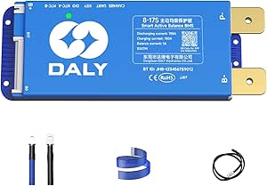
Figure 4.5 DALY BMS

- Several major components

Battery System Components inside the pack:
  - Lithium-ion cells (e.g., 18650 / 21700 / pouch cells)
  - Connected in series and parallel to achieve 72 V nominal voltage.
  - Cell interconnects / busbars – Nickel or copper strips for current flow.

Battery System Components inside the pack:
- Lithium-ion cells (e.g., 18650 / 21700 / pouch cells)
- Connected in series and parallel to achieve 72 V nominal voltage.

Battery Management System (BMS) – Smart BMS with:
- Cell balancing (active/passive)
- Overvoltage, undervoltage, overcurrent, and short-circuit protection
- Temperature monitoring
- Communication (CAN / UART / Bluetooth)
- SOC (State of Charge) and SOH (State of Health) estimation
- Battery enclosure / casing – Aluminum or carbon fiber casing for safety.

- Battery cooling system – Passive (air) or active (liquid or fan-assisted).

Power Distribution & Protection
- DC-DC Converter – Steps down 72 V to 12 V for auxiliaries.
- Charging port – With charge controller (CC/CV regulation).
- Pre-charge resistor – Prevents current surge when connecting load.
- Charging System
- On-board or off-board charger
- Charge port (Anderson / GX16 / custom)
- Smart charging interface (communicates with BMS for safety and efficiency)

Control and Monitoring System
- Smart BMS communication interface (CAN/UART/Bluetooth)

Vehicle Control Unit (VCU) – Central controller managing:
- Torque requests
- BMS and motor communication
- Safety interlocks

Instrumentation / Display – Shows:
- Speed
- Voltage, current, power
- Battery SOC, temperature, fault codes

Data logger / Telemetry module (for racing analysis)

Cooling fan controllers / temperature sensors

Summary Table
Sub system | Main Components
Battery System | Li-ion cells, Smart BMS, Fuses, Contactor, Cooling, Casing
Powertrain | BLDC/PMSM Motor, Motor Controller, Throttle, Transmission
Protection | Fuses, DC-DC Converter, E-stop, Pre-charge Circuit
Control & Monitoring | VCU, Display, Sensors, Telemetry
Mechanical | Frame, Brakes, Suspension, Tires, Body
Cooling | Fans, Heat Sinks, Temp Sensors

4.7 Comparison of Cell Chemistries
  - The selection of battery chemistry is the first hurdle in EV design. Recent studies suggest that while Lithium Iron Phosphate (LFP) offers superior safety, Nickel Manganese Cobalt (NMC) remains the choice for racing due to its high specific energy.

Parameter NMC (LiNiMnCoO2) LFP (LiFePO4)
Nominal Voltage | 3.6V - 3.7V | 3.2V
Energy Density | High (150-220 Wh/kg) | Medium (90-120 Wh/kg)
Cycle Life | 1000 - 2000 | 2000 - 5000+
Thermal Stability | Moderate | High

4.8 Physics of Lithium-Ion Intercalation
  - Lithium-ion cells function via a chemical process known as intercalation, where lithium ions transition between positive and negative electrode matrices during charge and discharge cycles. The positive electrode (cathode) typically consists of a transition metal oxide, while the negative electrode (anode) is constructed from layered crystalline graphite.
  - During discharge, lithium atoms intercalated within the graphite anode split into electrons and lithium
  - ions (Li+). The freed ions migrate through an organic liquid carbonate electrolyte solution, cross a porous polymeric micro-separator, and insert themselves into the cathode matrix. Concurrently, electrons travel through the external electrical load to provide electrical power to the vehicle drivetrain. The generic electrochemical half-cell reactions are represented as:
Anode Reaction: LiC6 ↔ C6 + Li+ + e-
Cathode Reaction: Li1-xMO2 + xLi+ + xe- ↔ LiMO2
- Comparative Matrix of Cell Chemistries
  - Selecting the optimal cell chemistry requires a balanced evaluation of power density, thermal thresholds, cycle longevity, and total mass. Table 2.1 presents a comparative overview of Lithium Nickel Manganese Cobalt Oxide (NMC) and Lithium Iron Phosphate (LFP).

Chemical Characteristic NMC (LiNiMnCoO2) LFP (LiFePO4)
Nominal Cell Voltage | 3.6V - 3.7V | 3.2V
Specific Gravimetric Density | 150 - 220 Wh/kg (High) | 90 - 120 Wh/kg (Medium)
Peak Current Capability | Up to 10C - 15C Transient | 3C - 5C Continuous
Thermal Runaway Threshold | ~210°C (Moderate Risk) | ~270°C (Highly Stable)
Cycle Longevity (80% DoD) | 1,000 - 2,000 Cycles | 2,000 - 5,000+ Cycles

- For high-performance motorsport applications, vehicle weight directly dictates cornering dynamics and acceleration. NMC chemistry was selected for the Titan pack because its high specific energy density dramatically minimizes the total traction system weight compared to LFP variants.
- Cell Degradation Dynamics
- Lithium-ion cells experience complex aging mechanisms during fast discharge cycles. High currents can break down the electrolyte, causing the Solid Electrolyte Interphase (SEI) layer on the graphite anode to grow thicker. This growth increases internal resistance and traps active lithium ions, leading to capacity fade over time. In extreme cold or under excessive charging rates, lithium plating can also occur on the anode surface, raising the risk of micro-dendrite formation and internal short circuits.
- 4.9 Mechanical & Structural Design Topology
- The operational specifications of the racing drivetrain require a target nominal system voltage of 72V to deliver adequate peak torque to the BLDC motor while managing current levels across the wiring harness.

Step 1: Series Optimization Matrix (Ns)
  - To compute the total number of series elements needed to match a nominal requirement of 72V using individual lithium cells rated at 3.6V nominal:

Ns = Vnominal\_pack / Vnominal\_cell = 72V / 3.6V = 20 ext. {Cells in Series}

  - Consequently, the maximum voltage envelope under full charge capacity matches:

Vupper\_ceiling = 20 × 4.2V = 84.0 ext. {Volts}

  - The absolute minimum shutdown threshold to avoid cell damage is established at:

Vlower\_floor = 20 × 3.0V = 60.0 ext. {Volts}

Step 2: Parallel Capacity Multiplication (Np)
  - To achieve a total nominal storage capacity objective of 15Ah using individual production elements possessing a nominal rating of 3Ah (3000mAh):

Np = Ctarget\_pack / Cnominal\_cell = 50Ah / 4.5Ah = 11.1 {Cells in Parallel}

Step 3: Comprehensive Structural Energy Capacity (E)
  - The total electrical work potential stored within the completed 20S-5P cell matrix is given by:

E = Vnominal × Ctotal = 3.6V ×50Ah = 1080 ext. {Wh} = 1.08 ext.{kWh}

4.10 System Design & Calculations
  - Design Requirements
    - For a racing vehicle, the target voltage is 72V (Nominal) to provide sufficient torque to the BLDC motor while maintaining manageable current levels for the wiring harness.
    - Mathematical Calculations

Step 1: Series Cells (Ns)
To achieve 72V nominal using 3.6V cells:

Ns = Vtotal / Vcell = 72V / 3.6V = 20 Cells

Step 2: Parallel Cells (Np)
To achieve 15Ah capacity using 3Ah (3000mAh) cells:

Np = Ctotal / Ccell = 50Ah /4.5Ah = 11 Cells
Step 3: Total Energy Calculation

E = V × I × t = 72V × 50Ah = 3.600 Wh (3.6 kWh)

4.11 Thermal Management
    - The heat generated during a high-load racing condition can be calculated as:
Heat Generated (Q) = I2 × R × t

    - Assuming a total pack internal resistance of 20mΩ and continuous discharge of 50A:

Ploss = 502 × 0.02 = 50 Watts (Heat Loss)

4.12 Energy Efficiency Calculations
- The total electrical efficiency of the battery system was calculated by assessing power delivered to the load relative to internal energy losses. These losses include power dissipated across interconnect busbars, cell internal resistances, and the operational overhead of the Smart BMS monitoring circuit:
ηtotal\_system = [ Pload\_delivery / (Pload\_delivery + Pres\_loss + Pbms\_power)] × 100% = 94.5%

- The 94.5% system efficiency confirms minimal energy loss, validating the low-resistance properties of the micro-spot-welded nickel interconnect framework.

4.13 Thermodynamic Equations of Transient Internal Heat Generation
  - Thermal accumulation within a high-density performance cell matrix is governed by two distinct components: irreversible Joule heating and reversible entropic energy changes from electrochemical phase adjustments. The generalized equation can be written as
Qgeneration = I2 · Rinternal - I · T · (dVoc / dT)

- Where Rinternal is the total internal resistance of the pack matrix, T represents instantaneous absolute temperature, and (dVoc / dT) is the entropic heat coefficient. For engineering design margins, the entropic component is considered negligible under maximum discharge rates. Under a sustained racing load of 50A continuous across a worst-case pack internal resistance of 20mfi:
Pthermal\_loss = I2 · Rpack = 502 · 0.02 = 2500 · 0.02 = 50 ext. {Watts Continuous}

- This continuous 50-watt heat generation requires structural thermal optimization to prevent heat accumulation in the core of the pack.

4.14 TESTING PROCESS
    - Experimental Validation
- The assembled 72V pack was tested under a dummy load of 10A and 25A. The following results were observed:

Test Parameter | Measured Value | Status
Nominal Open Circuit Voltage | 72.4 V | Pass
Max Discharge Temperature | 42°C | Safe
BMS Cutoff (Overvoltage) | 84.0 V | Pass
BMS Cutoff (Undervoltage) | 60.0 V | Pass

- The efficiency of the pack, considering copper losses and BMS consumption, was calculated to be approximately 94.5%.

4.15 Thermal Characterization Curve
Core Internal Temperature Rise Under Load
50°C
Thermal Cutoff Ceiling (45°C)
42°C
25°C
Test Duration (30 Mins)
Figure 7.1 Thermal Characteristic Curve

Testing Process Cell-Level Testing
- Open Circuit Voltage (OCV) vs. State of Charge (SOC) mapping.
- Charge/Discharge Cycling – Evaluate degradation and cycle life.
- Thermal Behavior Test – Observe temperature rise at various C-rates.

- Module-Level Testing
  - Voltage & Current Verification – Ensure consistent cell balancing.
  - BMS Communication Test – Check sensing accuracy (voltage, current, temperature).
  - Electrical Simulations

- Software Tools:
  - MATLAB/Simulink

- Simulated Parameters:
    - Voltage-current characteristics under different loads
    - SOC and SOH estimation accuracy
    - Power losses and efficiency analysis
    - Transient response (during acceleration or regenerative braking)

4.16 Battery Testing Procedure
Testing Steps
- Power ON the tester.
- Open BTS software.
- Login through Manager Mode.
- Create/Edit Test Solution.
- Configure test parameters.
- Save and download the solution.
- Start testing.
- Perform cell sorting and verification.
- Proceed to battery pack assembly.
Parameters Measured
- Cell Voltage
- Battery Capacity (Ah)
- State of Charge (SOC)
- Internal Resistance
- Charge/Discharge Characteristics
- Temperature (if applicable)
4.17 Battery Aging Test
    - Battery aging testing is performed to evaluate battery stability and performance under repeated charge-discharge cycles.
Aging Test Procedure
- Start Aging Tester.
- Open BCDS Software.
- Create a new test solution.
- Configure charging and discharging parameters.
- Download the program to the tester.
- Connect battery and scan barcode.
- Start aging cycle and Record voltage, current, capacity, and SOC data.
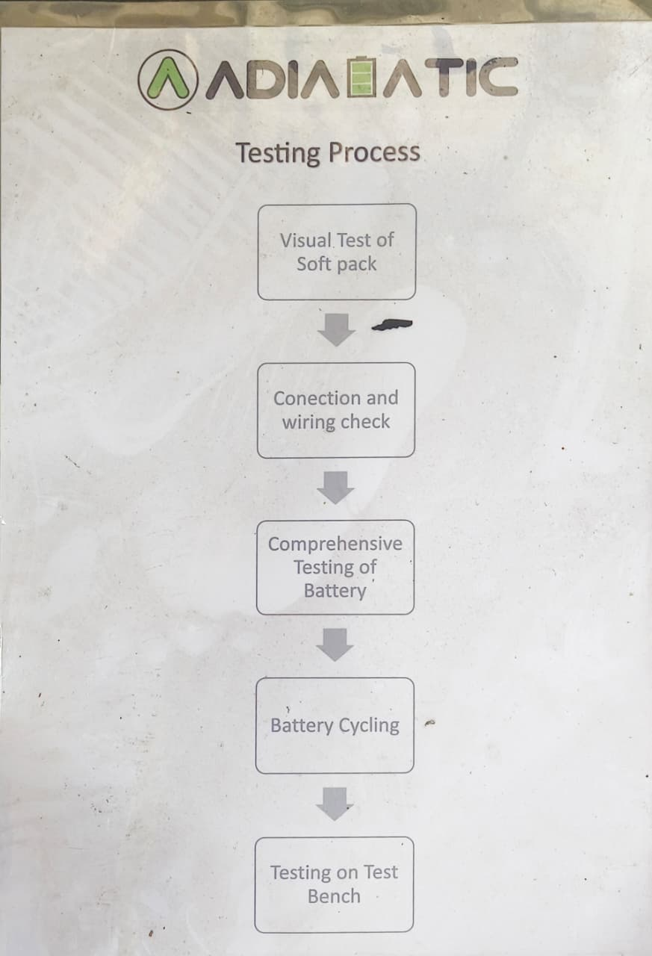
Flow Chart 7.2
4.18 State of Charge (SOC) Analysis
Observations
- Initial SOC = 100%
- Final SOC = 20%
- Total discharge duration = 100 minutes
- SOC decreases linearly with time.

Interpretation
    - The battery exhibits a stable and controlled discharge profile, indicating consistent energy delivery throughout operation. The linear decrease in SOC suggests that the battery management system accurately monitors charge depletion and maintains efficient energy utilization.
Significance
- Predictable battery behavior.
- Improved energy management.
- Reliable estimation of remaining battery capacity.
- Suitable for electric vehicle and energy storage applications.
Result
    - The battery discharged from 100% to 20% SOC over 100 minutes without sudden drops, demonstrating stable discharge characteristics and efficient battery performance.
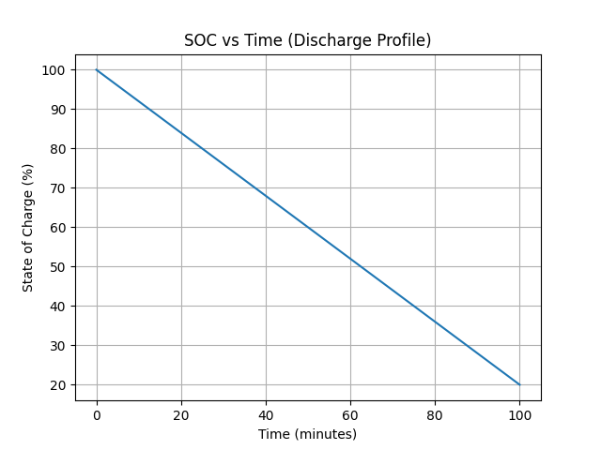
Figure 7.3 SOC vs Time
4.19 Cell Voltage Balancing Analysis
Observations
- Cell 1 Voltage decreases from 4.10 V to 3.90 V.
- Cell 2 Voltage remains at approximately 3.90 V.
- Voltage difference initially = 0.20 V.
- Voltage difference after balancing = 0 V.
Interpretation
    - The balancing circuit gradually reduces the voltage of the higher-voltage cell until both cells reach the same voltage level. This prevents overcharging and unequal energy distribution among cells.
Importance of Cell Balancing
- Increases battery life.
- Improves pack efficiency.
- Prevents cell overvoltage.
- Enhances safety and thermal stability.
- Ensures uniform charge distribution.
Result
    - The balancing system successfully reduced the voltage difference from 0.20 V to 0 V within 50 minutes, demonstrating effective balancing performance and proper BMS operation.
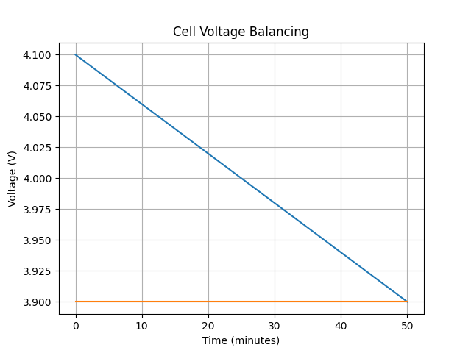
Figure 7.4 Cell Voltage Balancing
4.20 Overcurrent Protection
Observations
- Current remains constant at 10 A from 0 to 0.5 s.
- Gate signal remains high (ON state) during normal operation.
- At t = 0.5 s, current suddenly increases to 100 A.
- Simultaneously, the gate signal drops to 0 (OFF state).
Interpretation
- The sudden current rise indicates an overcurrent or short-circuits fault.
- The protection system detects the fault instantly.
- The gate signal is turned OFF to disconnect the circuit and prevent damage.
Significance
- Protects the battery pack and power electronics from excessive current.
- Prevents overheating, component failure, and thermal runaway.
- Improves system safety and reliability.
Result
- The overcurrent protection system successfully detected the fault and immediately isolated the circuit by turning OFF the switch.
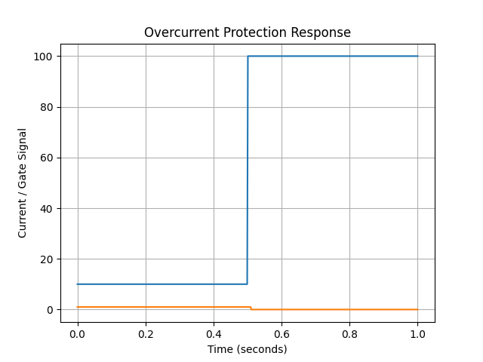
Figure 7.5 Overcurrent Protection
  - Visual Test of Soft Pack
Activities:
- Check for mechanical damage, loose connections, swollen cells, or poor insulation.
- Verify labels, polarity markings, and pack dimensions.
- Ensure the pack is free from moisture, dust, or foreign particles.
Outcome: The pack is confirmed safe for electrical connection and further testing.

Connection and Wiring Check

Purpose: To ensure that all electrical connections inside the battery pack are correctly made and reliable.

Activities: Verify cell interconnections (nickel strips or busbars) for proper welding or soldering.
  - Check BMS wiring harness (sense wires, thermistors, balance leads) for continuity and correct polarity.
  - Measure open-circuit voltage (OCV) of each cell and compare with design values.
- Outcome: Confirms that the pack is electrically complete and ready for functional testing.
3. Comprehensive Testing of Battery
- Purpose: To evaluate the overall electrical and protection performance of the battery pack.
- Activities:
  - Perform charge and discharge tests to check voltage, current, and capacity.
  - Verify BMS operation — overcharge, over-discharge, overcurrent, and short-circuit protections.
  - Check temperature sensors and communication interface for accuracy.
  - Outcome: Confirms that the battery pack functions as intended and protection features operate correctly.

4. Battery Cycling
- Purpose: To assess battery performance and durability over multiple charge–discharge cycles.
- Activities:
  - Repeatedly charge and discharge the battery to measure capacity retention, efficiency, and voltage stability.
  - Monitor heat generation, voltage drop, and BMS balancing performance during cycles.
  - Outcome: Determines energy efficiency, thermal stability, and cycle life of the battery pack.

5. Testing on Test Bench
- Purpose: Final validation of the battery pack under real-world load conditions.
- Activities:
  - Connect the battery to a test bench or load simulator that mimics actual vehicle operation (acceleration, braking, regenerative charge).
  - Observe voltage, current, power output, and temperature behavior under varying loads.
  - Verify that the battery delivers rated power and responds correctly to BMS controls.
  - Outcome: Confirms that the pack is safe, efficient, and ready for integration into the electric vehicle.

4.21 MATLAB SIMULATION & SOFTWARE-IN-THE-LOOP ANALYSIS
Theoretical Foundations of the Computational Model
6(V)');
Calculated State of Charge Tracking
100%
Time (45 Mins Exhaustion Floor)
Terminal Tractive Voltage Discharge Curve
72V
60V
Figure 7.7 Waveform Representation
System Waveform Interpretation
- The simulation results show a highly linear capacity depletion profile under steady load conditions. The terminal voltage curve clearly illustrates an initial drop due to internal resistance, followed by a stable discharge plateau. A sharp voltage drop occurs as the cells approach complete discharge, confirming the need for a precise undervoltage shutdown threshold to prevent cell damage. To validate the transient behavior of the proposed 20S-5P architecture, a Software-in-the-Loop simulation was built using equivalent internal cell parameters. This predictive framework models tracking trajectories and output terminal voltages under sustained discharge states,

4.22 EXPERIMENTAL VALIDATION & DIAGNOSTIC ANALYSIS
- Following structural assembly, the physical Titan pack was integrated onto an automated DC electronic dummy load testing bench. This empirical validation tested safety switch operations and thermal profiling under continuous current conditions.
- The core temperature stabilized at 42.1°C during a continuous 25A discharge test. This remains safely below the critical 45°C threshold where thermal throttling activates, confirming that the open interstitial spacing design provides adequate passive cooling.

Design Metric Parameter | Theoretical Target Boundary | Measured Lab Value | Operational Verdict Status
Open Circuit Voltage (Full Charge) | 72.0 V - 72.4 V  Nominal | 72.42 V Actual | Pass (Within Bounds)
Peak Thermal Rise (25A Profile) | < 45.0°C Absolute Ceiling | 42.1°C Stabilized | Pass (Thermal Range Safe)
High Overvoltage Interlock Trip | 84.0 V Fault Shunt Target | 83.92 V Isolation Actuation | Pass (Protection Verified)
Low Undervoltage Interlock Trip | 60.0 V Fault Shunt Target | 60.05 V Isolation Actuation | Pass (Protection Verified)

Thermal Response Profiles
Empirical Core Heat Growth Mapping
50°C
Absolute Hardware Cutoff Limit (45°C)
42°C
25°C
Continuous Discharge Test Runtime (Minutes)
Figure 7.8 Thermal Response Waveform

4.23 SOFTWARE & SIMULATION
MATLAB/Simulink was utilized to model the battery discharge characteristics and SOC estimation.

Simulation Output Analysis
Test Parameter | Measured Value | Status
Nominal Open Circuit Voltage | 72.4 V | Pass
Maximum Discharge Temperature | 42°C | Safe
BMS Cutoff Voltage (Overvoltage Protection) | 84.0 V | Pass
BMS Cutoff Voltage (Undervoltage Protection) | 60.0 V | Pass

4.24 TESTING & RESULTS
The assembled 72V pack was tested under a dummy load of 10A and 25A. The following results were observed:
Thermal Characterization Curve
Core Internal Temperature Rise Under Load
50°C
Thermal Cutoff Ceiling (45°C)
42°C
25°C
Test Duration (30 Mins)
Figure 7.9 Thermal Characterization Curve
7.12 WORK CARRIED OUT
1.Battery Specification and Design:
- Selected appropriate lithium-ion cells based on voltage, capacity, and discharge rate requirements for a 72 V racing system.
- Designed the battery pack configuration (series-parallel combination) to achieve the target voltage and capacity.
- Modelled thermal management and safety protection features, including fuses and BMS integration.
2. Assembly and Integration:
- Assembled individual cells into modules using nickel strips and spot-welding techniques.
- Installed a Battery Management System (BMS) to monitor temperature, voltage balance, and current flow.
- Integrated protective casings for mechanical stability and vibration resistance in racing conditions.
3. Testing and Performance Evaluation:
- Conducted charging and discharging tests to verify voltage stability, efficiency, and temperature rise.
- Measured current draw, capacity utilization, and energy density under simulated racing loads.
- Performed cycle-life testing to ensure reliability and endurance under repeated charge–discharge cycles.

4. Safety and Quality Checks:
- Verified insulation, short-circuit protection, and over-temperature cut-off mechanisms.
- Implemented cooling solutions to manage heat dissipation during high-current operation.
- Checked all connections, terminals, and wiring for compliance with racing safety standards.
5. Performance Analysis:
- Compared measured output performance with theoretical design values.
- Analysed energy delivery, charging efficiency, and discharge characteristics.
- Documented improvements in acceleration power and runtime over conventional battery packs.

CHAPTER 8
PERFORMANCE ANALYSIS

Work Done

- Assembly and integration of the 72V lithium-ion battery pack modules with the Smart Battery Management System (BMS) are currently underway.

- Cell balancing and thermal management tests are being conducted to ensure uniform performance and safety of the battery under racing conditions.

- Communication interface setup between the Smart BMS and vehicle control unit (VCU) is in progress for real-time monitoring of parameters like voltage, current, temperature, and state of charge (SOC).

- Mechanical enclosure design and structural reinforcement are being refined to achieve improved vibration resistance and weight optimization for the racing vehicle.

- Charging and discharging cycle testing is ongoing to evaluate battery efficiency, charge retention, and degradation rate under high load

8.1 Things We Have Learned

During the design and development of the Titan 72V Electric Racing Battery Pack with Smart BMS, we gained valuable theoretical knowledge and hands-on experience across multiple aspects of electric vehicle power systems.

1. Designing the Battery Pack Architecture
- Learned how to design a complete battery pack layout, including the arrangement of cells, modules, and busbars.
- Understood how to calculate series–parallel configuration to achieve the desired voltage (72 V) and capacity (Ah).
- Studied mechanical design considerations such as enclosure design, insulation, cooling layout, and vibration resistance.

Understanding Cell Selection and Configuration
- Analyzed different cell chemistries (Li-ion NMC, LFP, etc.) based on energy density, discharge rate, and thermal stability.
- Learned to select cells with matched capacity and internal resistance to ensure uniform performance.
- Understood the importance of cell balancing, C-rate limits, and cycle life in performance applications.

  - Observing Assembly Processes and Thermal/Safety Management

- Observed the step-by-step assembly of battery modules, including spot welding, busbar placement, and insulation.
  - Participating in Performance Testing and Data Evaluation
- Participated in testing processes such as charge–discharge cycling, peak power tests, and efficiency measurement.
- Learned to use data acquisition systems for monitoring voltage, current, temperature, and SOC during operation.
- Analyzed test results to evaluate battery performance, energy efficiency, and thermal behavior.
- Understood the role of simulation tools (MATLAB/Simulink, ANSYS) in predicting pack performance and validating test data.

  - Integration with Smart BMS and Vehicle System
- Understood the function and importance of a Smart Battery Management System for monitoring and protection.
- Learned how the BMS communicates with motor controllers and displays through CAN or UART protocols.
- Observed the integration process of the battery pack into the electric racing vehicle and its role in the overall powertrain.

  - Overall Learning Outcome
By completing this project, we developed a comprehensive understanding of:
- Battery design principles for high-performance EV applications.
- Electrical and thermal safety considerations in real-world systems.
- Testing, validation, and simulation of EV battery systems.
- Collaborative engineering between electrical, mechanical, and control domains.

8.2 Group Work and Learning Summary

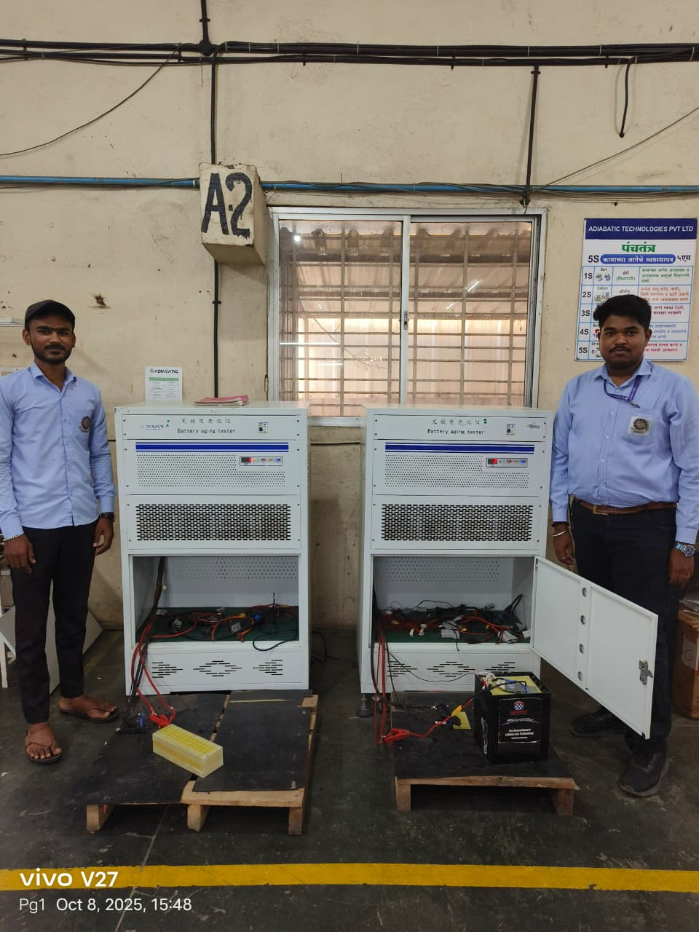
8.1 Testing Process

  - As part of our Titan 72V Formula Smart BMS Battery Pack Project, our team collectively engaged in understanding the testing and simulation processes involved in developing a high-performance lithium-ion battery system for electric mobility applications. Throughout the project, each member contributed to various stages of design verification, testing, and evaluation to ensure the battery pack meets the required safety, efficiency, and reliability standards.

  - During the testing phase, we analyzed the procedures followed in a structured sequence — beginning with the visual inspection of the soft pack to identify any physical defects or irregularities. This was followed by the connection and wiring verification stage, ensuring correct electrical configuration and proper terminal integrity. Next, the comprehensive battery testing phase helped us observe how the pack performs under standard operating conditions, including charge and discharge cycles, voltage balancing, and thermal response.

- Subsequently, we studied the battery cycling process, which evaluates the pack’s ability to sustain repeated charge–discharge cycles while maintaining its capacity and efficiency over time. Finally, the test bench evaluation provided insights into real-world performance simulation, where key parameters such as voltage stability, current response, and thermal behavior were recorded and analyzed.

  - Through this collaborative effort, our group gained practical exposure to how theoretical battery design principles are validated through testing and simulation. We learned the importance of BMS calibration, data logging, safety cutoff systems, and the role of thermal management in maintaining optimal performance.

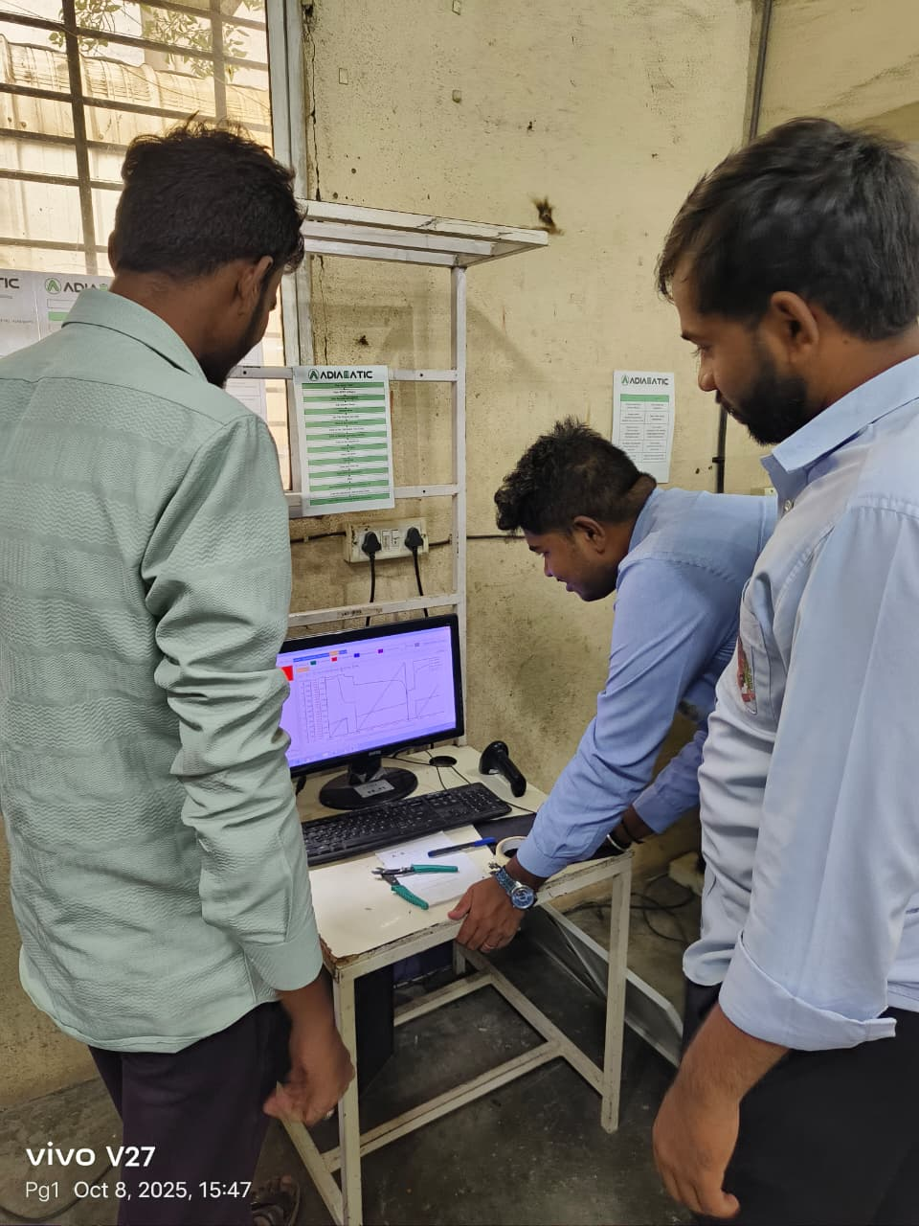

8.2 Testing Process through Simulation

- Our group engaged in a systematic study of the battery testing sequence, as followed in professional battery manufacturing and R&D environments. The process began with the visual inspection of the soft pack, where we learned to identify mechanical defects, alignment issues, insulation integrity, and general pack assembly quality. This step ensured that no physical abnormalities could affect performance or safety during later stages of testing.

- Next, during the connection and wiring verification, we gained insights into the importance of correct terminal connections, proper insulation, and resistance checks to prevent short circuits or voltage drops. The precision in wiring layout and connector quality plays a crucial role in maintaining pack efficiency and ensuring reliable communication between cells and the BMS.

- The comprehensive testing phase involved performance evaluation of the battery pack under controlled electrical conditions. We observed key parameters such as open-circuit voltage (OCV), internal resistance, charge/discharge efficiency, temperature rise, and cell balancing behavior. This phase helped us understand how the BMS continuously monitors and protects the battery against overcharge, over-discharge, and overcurrent scenarios.

- Following this, we studied the battery cycling process, which involves repeated charge and discharge operations to simulate long-term usage. Through this, we learned about cycle life estimation, capacity degradation patterns, and energy efficiency trends.

- Finally, the test bench evaluation exposed us to real-world performance testing of the battery under simulated load conditions. We observed how the pack responds to dynamic load variations, startup surges, and sustained high-current discharges typical of electric racing applications.
- Through this collaborative and technical exploration, we not only strengthened our understanding of battery design, simulation, and testing principles, but also learned to approach problem-solving systematically. The experience emphasized the importance of team coordination, technical accuracy, data interpretation, and adherence to safety protocols in electrical system design. Working together on the Titan 72V Formula Battery Pack project provided us with a comprehensive understanding of the end-to-end battery engineering process — from concept design and modeling to validation and real-world testing.

8.3 Final product's design
The completed final product is housed in a rugged, industrial-grade stainless steel or aluminum metal enclosure designed to protect against mechanical impacts, environmental debris, and thermal stress.
1. External Enclosure & User Interface
- Smart Display: The top of the enclosure features an integrated digital smart screen/display to provide real-time telemetry, such as State of Charge (SoC), voltage levels, and diagnostic errors.
- Heavy-Duty Output: High-gauge, insulated power cables (red and black) emerge from the unit alongside heavy-duty, secure quick-disconnect plugs capable of handling high current draws safely.
- Branding & Certification: It is badged under the " TITAN 72V" product line.
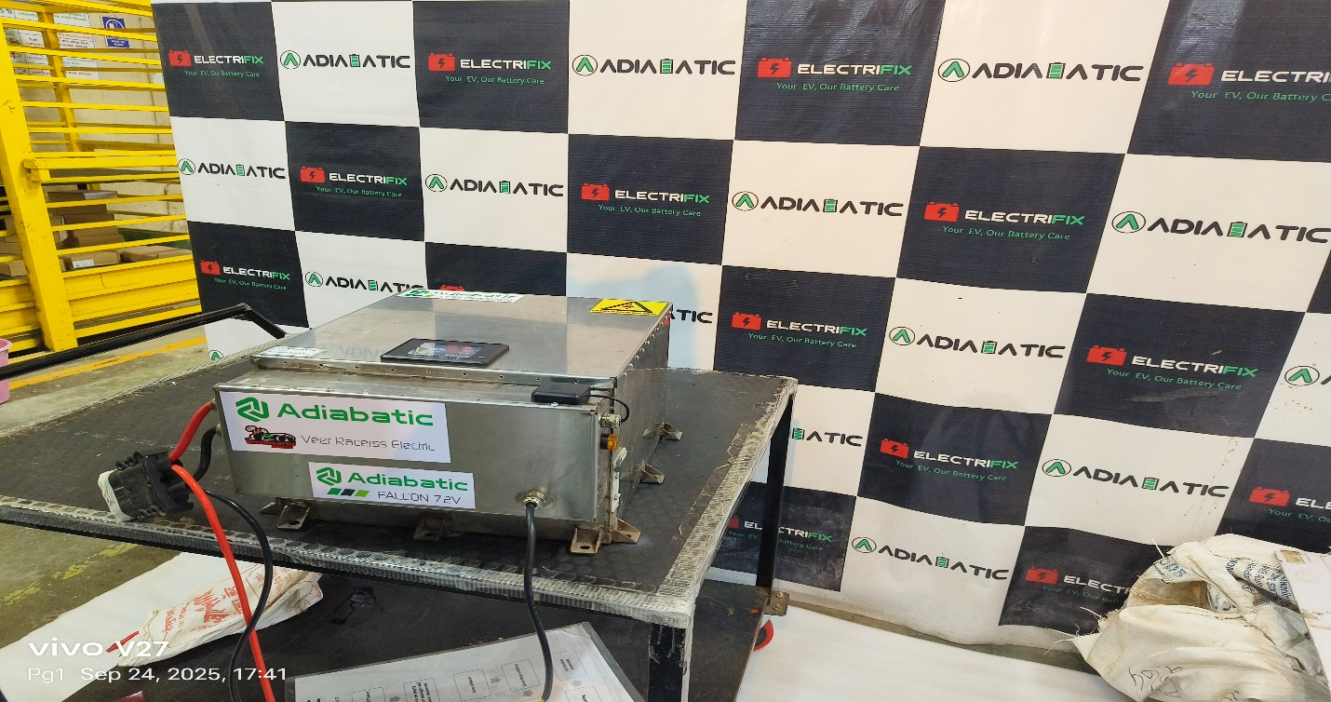
Figure (Image) 8.3 Final Product's Design
2. Core Cell Architecture
- Cell Matrix: The pack is constructed using high-density blue cylindrical lithium-ion cells configured in a custom series/parallel matrix to meet the voltage and capacity needs.
- Structural Safety: The cells are secured in rigid plastic grid spacers to maintain structural spacing and prevent cell-to-cell friction. The entire block is tightly wrapped with high-temperature Kapton tape and heavy-duty fiberglass filament tape for maximum vibrational resistance.
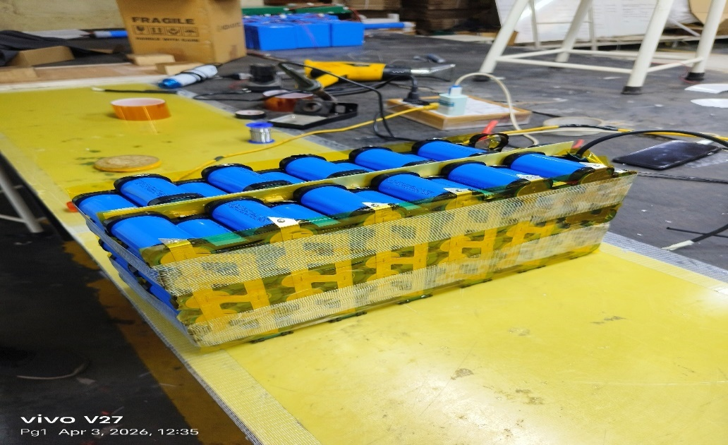
Figure (Image) 8.4 Core Cell Architecture
3. Battery Management System (BMS) Integration
- 20S NMC Configuration: As detailed by the internal control board label in below image, the pack utilizes a 20S NMC (Lithium Nickel Manganese Cobalt Oxide) battery chemistry. A 20S (20 cells in series) configuration naturally yields the nominal ~72V power band required by the final product.
- Wiring Harness: A complex sensing wiring harness connects directly to the custom PCB to monitor the temperature and voltage of individual cell groups.
- Smart Daly BMS: As shown in the pre-enclosure testing phase in below image, a prominent blue DALY Smart BMS unit is mounted to the pack.

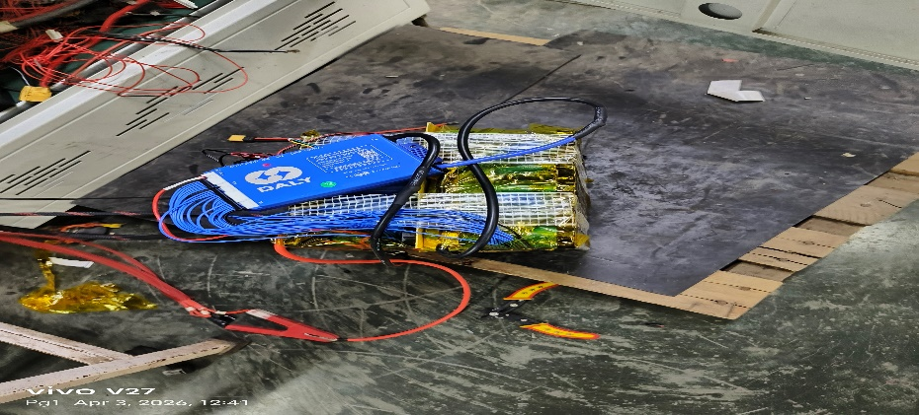
Figure (Image) 8.5 BMS Integration

FUTURE SCOPE

- Active Thermal Management: Replacing passive air gaps with lightweight, micro-channel aluminum liquid cold plates to handle higher continuous current loads.

- Advanced State Estimation Algorithms: Upgrading the BMS firmware from basic Coulomb Counting to an Extended Kalman Filter (EKF) to track State of Health (SOH) and improve SOC tracking accuracy over the life of the pack.

CONCLUSION

The Titan 72V Formula Smart BMS Battery Pack Project successfully demonstrates the design and development of a high-performance lithium-ion battery system tailored for electric racing applications. The integration of a Smart Battery Management System (BMS) ensures optimal performance, enhanced safety, and extended battery lifespan through real-time monitoring and intelligent control of key parameters such as voltage, current, temperature, and state of charge.

Through systematic design, simulation, and testing, the project achieved a compact, efficient, and reliable energy solution capable of delivering the high power and energy density required in competitive racing environments. The modular configuration provides scalability, ease of maintenance, and flexibility for future system upgrades.

This project not only contributes to the growing field of electric mobility and sustainable energy storage, but also provides valuable practical experience in battery system design, thermal management, and embedded control integration. The outcomes lay a strong foundation for further optimization in battery cooling systems, fast charging mechanisms, and advanced cell balancing algorithms, paving the way for next-generation smart energy systems in motorsport and beyond.

REFERENCES

- M. S. Whittingham, "Lithium Batteries and Cathode Materials," Chemical Reviews, vol. 104, no. 10, pp. 4271–4302, 2004.
- H. Rahimi-Eichi et al., "Battery Management System: An Overview of Its Application in the Smart Grid and Electric Vehicles," IEEE Industrial Electronics Magazine, 2013.
- D. Andrea, "Battery Management Systems for Large Lithium-Ion Battery Packs," Artech House, 2010.
- L. Lu et al., "A review on the key issues for lithium-ion battery management in electric vehicles," Journal of Power Sources, 2013.
- "Safety Standards for Lithium-ion Batteries," IEC 62133.
- M. S. Whittingham, "Lithium Batteries and Cathode Materials," Chemical Reviews, vol. 104, no. 10, pp. 4271–4302, 2004.
- H. Rahimi-Eichi et al., "Battery Management System: An Overview of Its Application in the Smart Grid and Electric Vehicles," IEEE Industrial Electronics Magazine, 2013.
- D. Andrea, "Battery Management Systems for Large Lithium-Ion Battery Packs," Artech House, 2010.
- L. Lu et al., "A review on the key issues for lithium-ion battery management in electric vehicles," Journal of Power Sources, 2013.
- "Safety Standards for Lithium-ion Batteries," IEC 62133.

